**Performance Evaluation of Internal Combustion Engine Powered Pneumatic Drilling Machine Using Fault Tree Analysis.**

**BY**

**SHUAIBU USMAN GIMBA**

**(****19/405MEEV/002)**

**DEPARTMENT OF MECHANICAL ENGINEERING**

**UNIVERSITY OF ABUJA, NIGERIA**

**BEING THE SECOND PROGRESS REPORT**

**PRESENTED TO THE DEPARTMENT OF MECHANICAL ENGINEERING,**

**UNIVERSITY OF ABUJA, NIGERIA, IN PARTIAL FULFILLMENT OF THE**

**REQUIREMENTS FOR THE AWARD OF ENERGY/THERMOFLUID**

**DEGREE IN MECHANICAL**

**ENGINEERING**

**SUPERVISORS:**

1. **Prof. I.I. Ozigis**
2. **Dr Lawal Nuhu**

**October 2023**

Contents

1.1. Background 3

1.2. Statement of the Problem 5

1.3 Significance of Research 6

1.4 Aims and Objectives 6

1.4.1 Aim 6

1.4.2 Objectives 6

1.5 Methodology 7

1.6 Scope of the Study 7

1.7 Limitations 7

2 LITERATURE REVIEW 8

2.1 History of Drilling Machines 8

**2.2** **Theoretical Framework** 9

**2.3** **Performance Analysis of Internal Combustion Engine** 13

**2.4** **Electrical, Hydraulic, and Pneumatic Drilling Machine** 13

**2.5** **Fault Tree Analysis** 14

3 CHAPTER THREE 16

**3.1** **Materials and Methods** 16

**3.2** **Research Design** 16

3.3 Machine Design 16

3.3.1 Reciprocating Engine Model 16

3.3.2 Engine Component Design 18

3.3.3 Engine Fuel and Air System 21

3.4 Corrective Maintenance 25

3.4.1 Modeling Corrective Maintenance 26

3.4.2 Modeling Noise and Vibration 28

**3.5** **Data Collection** 30

3.5.1 Review 30

**3.5.2** **Case Studies and Observations** 30

**3.6** **Analytical Approach** 30

**3.6.1** **Fault Tree Analysis (FTA)** 30

**3.6.2** **Fault Tree Analysis Design** 31

**3.6.3** **Probability Theory** 35

**3.6.4** **Fault Tree Repair Strategy** 38

**4.3** **Minimum Cut-Set** 47

4.4 Reliability and Availability 47

4.5 Failure Probability and Unavailability 50

4.6 Discussion 50

4.7 Operational Parameters 51

5 CHAPTER FIVE 53

5.1 Conclusion 53

5.2 Recommendation 53

6 GLOSSARY 58

Symbols Nomenclatures 58

7 APPENDIX A 59

8 APPENDIX B 60

**Normalize the Weighted Averages to Probabilities** 62

**Computing Probabilities** 62

9 APPENDIX C 63

CHAPTER ONE

## Background

The technological advances in today’s products are making some useful engineering artifacts look somewhat obsolete, causing them to vanish both from manufacturing industries and the market. Furthermore, these advanced products may not be suitable for all regions and markets due to deficits in infrastructural development in certain parts of the world. Therefore, the usability of a product in a particular region will require continuous support for maintenance and redesign to improve efficiency.

In cases where support for maintenance, redesign, and documentation of an individual component of machinery is completely stopped, reverse engineering of the machine or product must be done to create the geometric configuration and properties for continuous support during component replacement when maintenance arises.

Internal combustion engine-powered pneumatic drills are among the most versatile machines used in the construction industry for various utility operations, despite their complexity in housing three different machines working harmoniously. The performance of these drills is critical for the success of construction projects, as they are designed to operate under extreme conditions. The reliability and safety of these drills depend on their design, materials, maintenance, usage, and operating environment. System failures could result in catastrophes leading to high maintenance costs, safety hazards, production loss, and downtime.

Developed countries are shifting towards using electric drives for pneumatic drills, as these machines are more efficient and require less maintenance. However, maintenance can be challenging for less developed nations that lack the technical and infrastructural capabilities to design and manufacture these machines. Therefore, a methodology for continuous support, redesign, and maintenance must be sorted out locally to render these machines useful until they break even and achieve the required return on investment (ROI).

Artificial intelligence (AI) has revolutionized performance evaluation in various fields, including predictive maintenance and fault detection. Predictive maintenance involves using machine learning algorithms to analyze data and identify patterns that can indicate potential issues before they cause major problems. Fault detection involves using AI to analyze data and identify anomalies that could indicate the presence of a fault.

AI can be particularly useful in the performance evaluation of pneumatic drills, as they generate large amounts of data during their operation. By analyzing this data, AI can identify patterns and anomalies that can indicate potential issues with the drills. For example, AI can be used to detect when a pneumatic drill is starting to wear down, allowing maintenance personnel to perform preventative maintenance before the drill breaks down.

Furthermore, AI can be used to analyze data from multiple pneumatic drills, identifying patterns and correlations between different variables. For example, AI could identify a correlation between the usage of a particular pneumatic drill and the amount of maintenance it requires, allowing maintenance personnel to optimize the usage of the drills and reduce maintenance costs [1].

Internal Combustion Engine-Powered Pneumatic Drills are versatile machines that are commonly used in the construction industry for drilling and other utility operations. These machines work by using compressed air generated by an internal combustion engine to power a pneumatic hammer or drill.

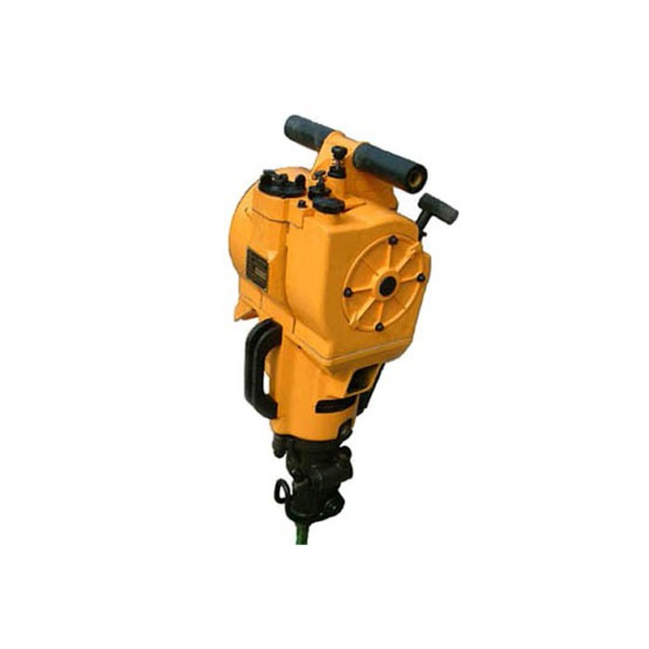

Figure 1.1 ICE-Powered Pneumatic Drilling Machine.

One of the main advantages of these drills is their portability, as they do not require a power source other than fuel to operate. However, they are also known to be noisy, emit exhaust gases, and require regular maintenance to ensure their reliable and safe operation.

Recent research has focused on improving the performance of internal combustion engine-powered pneumatic drills through the use of advanced technologies such as predictive maintenance and fault detection. By using sensors and data analysis tools, it is possible to monitor the performance of these machines and identify potential issues before they become major problems, reducing downtime and maintenance costs [2] [2].

## Statement of the Problem

The level of machinery automation found in industrialized nations is on par with their infrastructural development and is incomparable with that of developing countries in Africa. For this reason, the mechanization of day-to-day activities in construction sites, farmlands, and exploration sites tend to use equipment that matches the local environmental infrastructure.

However, many of the machines used as mechanized equipment are manufactured by developed nations. Whenever those machines are phased out of production due to advancements in technology, spare parts and documentation for repairs become very difficult to obtain. In some instances, the machine becomes useless while it has not yet broken even from its cost of purchase. Therefore, the problems are summarized as follows:

* Lack of spare parts for the replacement of defective ones
* Higher cost of maintenance
* Longer labor hours due to lack of maintenance/repair guide
* Reduced machine efficiency resulting from overloading

## Significance of research

There are quite several machines in most of our institution laboratories which are not put to use due to break-down While possible means of repair are highly expensive, the actualization of a project such as this one will usher a new methodology to the dilemma of maintenance and repair of most pieces of machinery.

## Aims and Objectives

### Aim

This research proposal aims to evaluate the performance of internal combustion engine-powered pneumatic drills through the application of fault tree analysis techniques to come up with a detailed cause-to-effect failure.

### Objectives

* Utilize Fault Tree Analysis (FTA) to identify and analyze potential failure modes in pneumatic drilling machines.
* Apply Bayesian Network (BN) modeling to quantify the probabilities of these failures and their interdependencies.
* Develop a predictive maintenance framework that integrates FTA and BN to optimize machine performance and reliability.
* Performance evaluation of the drilling machine (Speed of drill and rate of penetration, vibration rate, and flue gas analysis).

## Methodology

The thesis is structured as follows: the literature review provides an overview of previous work in fault analysis and predictive maintenance; the methodology section details the FTA and BN modeling approach; FTA according to [3] is a deductive approach involving the graphical enumeration and analysis of the different ways in which a particular system failure can occur and the probability of its occurrence. The top-level event will be identified and emphasis placed on this top-level event and the first-tier causes related to the primary system failure. Next is the thorough investigation of each cause of the system failure in a top-down hierarchy. The results section presents the findings of the study; the discussion interprets these results in the context of current industry practices; and the conclusion summarizes the key insights and suggests directions for future research.

## Scope of the Study

The study focuses on evaluating the performance of internal combustion engine-powered pneumatic drilling machines using Fault Tree Analysis (FTA) and FTA-Bayesian network (BN) modeling. The main objectives include identifying critical components and failure modes, modeling potential failure pathways, and assessing the reliability, availability, and performance of these drilling machines under various operational conditions.

## Limitations

* The study relies on expert opinions to generate ratings for basic events in the Bayesian network. These ratings, although weighted, can introduce subjective biases that may affect the results. Therefore, the potency of data collected is wholly because of human inaccuracies and it is subject to refinement and criticism.
* The findings and recommendations are specific to the types of internal combustion engine-powered pneumatic drilling machines studied and may not be directly applicable to other types or models of drilling machines without further validation.
* Rapid advancements in drilling technologies and changes in machine designs could make some aspects of the study obsolete or less relevant over time.

CHAPTER TWO

# LITERATURE REVIEW

## History of Drilling Machines

## The 19th century witnessed advancements in pneumatic technology, with Samuel Ingersoll's invention of the pneumatic drill in 1871, revolutionizing industries reliant on drilling operations. Charles Brady King, a Detroit inventor, left his indelible mark in 1890 when he conceived and subsequently patented the pneumatic hammer—a tool driven by compressed air, earning its patent on January 28, 1894. King's innovations didn't stop there; he showcased two of his groundbreaking creations at the 1893 World's Columbian Exposition: a pneumatic hammer designed for riveting and caulking and a steel brake beam tailored for railroad road cars [4] [5].

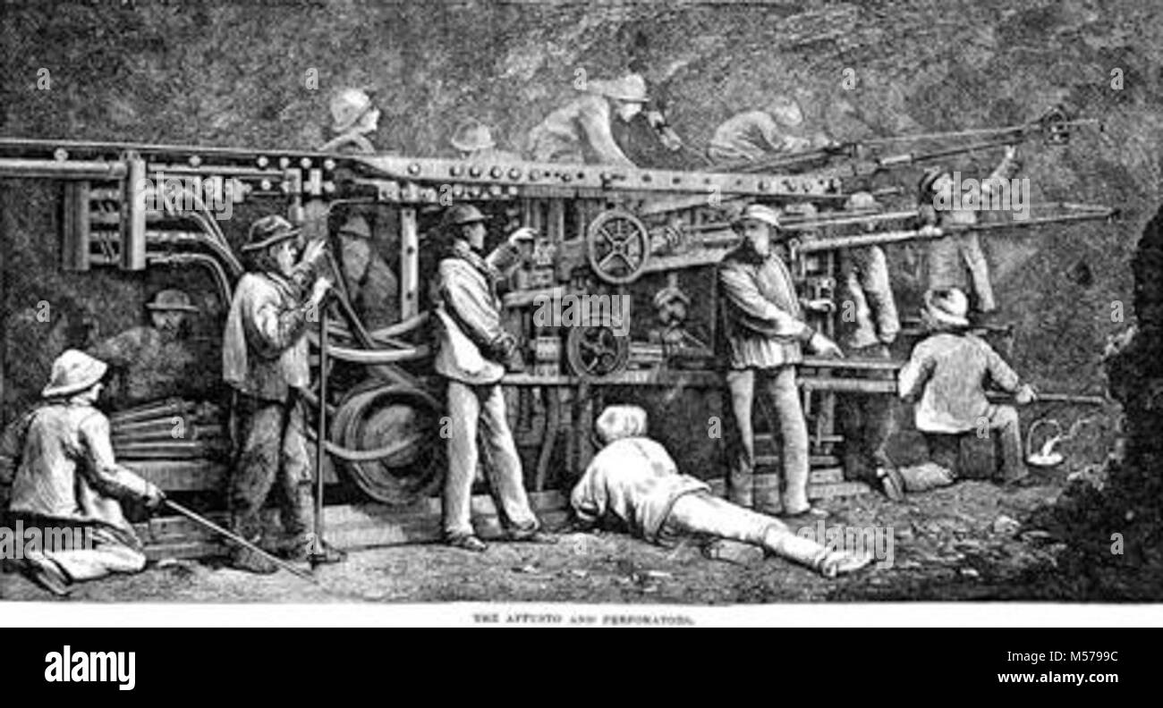

Figure 2.1 Pneumatic Drilling Machine. [www.alamy.com](http://www.alamy.com)

As the 20th century dawned, the widespread adoption of compressed air and compressed-air devices ushered in a new era of productivity and automation. Jet engines, for instance, integrated centrifugal and axial-flow compressors, contributing to the aviation industry's growth. Meanwhile, pneumatics became indispensable in various industries, powering automatic machinery, labor-saving devices, and sophisticated automatic control systems.

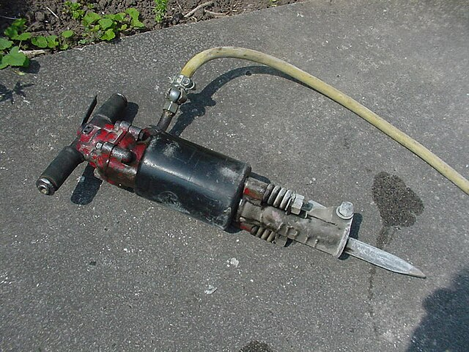

Figure 2.2 Pneumatic drill.

Notably, it was during the late 1960s that the landscape of pneumatic control underwent a transformative shift with the emergence of digital-logic pneumatic control components. This technological leap brought enhanced precision and efficiency to numerous sectors, from manufacturing and robotics to aerospace and beyond. In this way, pneumatic technology continues to evolve, leaving an indelible imprint on the ever-advancing tapestry (complexity or richness of design) of human innovation

## **Theoretical Framework**

The performance evaluation of an internal combustion engine-powered pneumatic drill involves the application of several theoretical concepts and models to assess various aspects of its operation. In essence, the performance evaluation of an internal combustion engine-powered pneumatic drill relies on a multidisciplinary approach that combines principles from thermodynamics, mechanics, fluid dynamics, combustion theory, and control systems.

**Petrol Powered Engine**: Thermodynamics plays a central role in understanding the internal combustion engine's operation. Concepts like the Brayton cycle (for gas turbines) or the Otto and Diesel cycles (for reciprocating engines) help in analyzing the thermodynamic efficiency of the engine. This involves understanding how the engine converts chemical energy from fuel into mechanical work and the losses associated with this process [6].

**In the Pressure (P) Volume (V) diagram, Mean Effective Pressure (MEP) is the pressure inside the cylinder or combustion chamber, is the network delivery while and are the minimum and maximum volume of the cylinder.**

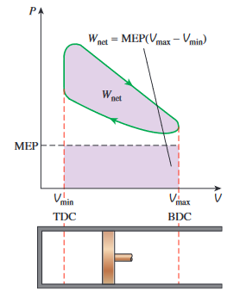

Figure 2.3 Otto Cycle. [6].

**Combustion Theory**: Understanding the combustion process within the internal combustion engine is essential. The ideal gas law, chemical kinetics, and combustion modeling help in predicting and optimizing the combustion efficiency, emissions, and power output of the engine [7].

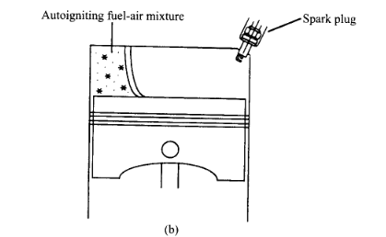

Figure 2.4 Flame Combustion [7].

**Energy Conversion**: Theoretical concepts related to energy conversion are fundamental to understanding how energy is transformed from chemical (fuel) energy to mechanical energy (work output) in the engine. Concepts like energy balance equations help assess the efficiency of this conversion process.

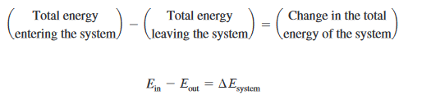2.1

**Vibration Analysis**: Vibration analysis theories are used to evaluate the structural integrity of the pneumatic drill and its components. Excessive vibrations can lead to wear and tear, affecting performance and safety. Excitation induced by a single cylinder assuming the crankshaft rotates at a constant angular speed then the displacement X is:

`2.2

where , r is the radius of the crank and l is the length of the connecting rod refer to figure 10.

**Control Systems**: Control theory is applied to design and optimize engine management systems, which play a crucial role in regulating factors such as air-fuel mixture, ignition timing, and exhaust emissions. Feedback control systems are often employed to maintain optimal engine performance.

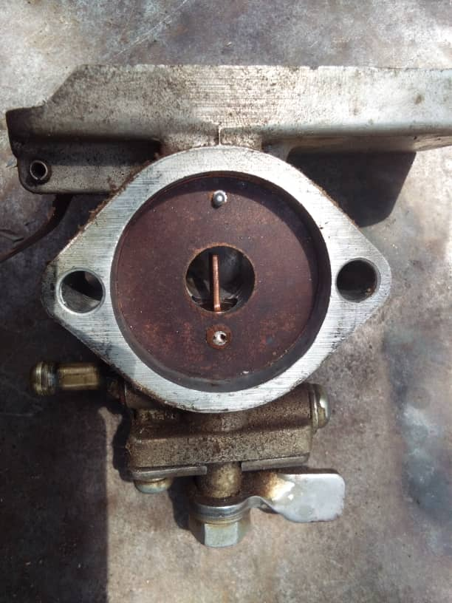

Figure 2.5 Carburetor

**Efficiency Models**: Various efficiency models, such as thermal efficiency, mechanical efficiency, and volumetric efficiency, are used to quantify how effectively the engine converts fuel energy into useful work and to identify areas for improvement.

 2.3

**Emission Models**: Environmental considerations are increasingly important in engine performance evaluation. Models for predicting emissions of pollutants like nitrogen oxides (NOx), carbon monoxide (CO), and particulate matter (PM) are essential for compliance with emission standards.

**Emission index is given by the ratio of the mass of species i to the mass of fuel burned by the combustion process.**

**------------- 2.4**

## **Performance Analysis of Internal Combustion Engine**

Analysis of the performance of a two-stroke engine was carried out by [8]. The study analyzes the performance of a compressed ignition engine using compressed air as fuel, with modifications made to the engine's camshaft and cycle. The maximum power obtained was 0.89 Kw at an air pressure of 800 KPa and an engine speed of 1620 rpm, while the maximum torque was 9.91 Nm at an engine speed of 545 rpm. The consumption of compressed air increased to 1050 L/min to achieve the engine speed of 1620 rpm. The outlet pressure during the experiment increased from 150 KPa to 225 KPa, which can be stored or directly fed to the storage tank. A blend of methanol and gasoline in a copper-coated engine was researched by [9]. The copper-coated engine with methanol blended gasoline significantly improved performance compared to the conventional engine (CE) with pure gasoline operation. It increased brake thermal efficiency, decreased brake-specific energy consumption, decreased exhaust gas temperature, and increased volumetric efficiency. However volumetric efficiency decreased with an increase in brake mean effective pressure due to an increase in gas temperature.

## **Electrical, Hydraulic, and Pneumatic Drilling Machine**

Over the past 25 years, advancements in technology have led to the creation of numerous new products and significant enhancements to existing ones in the drilling construction industry. For instance, the introduction of improved material grades, and enhanced comprehension of rock properties, along with more precise heat-treatment techniques, strength assessments, and computer simulations, have resulted in a contemporary powered drifter rock drill now delivering approximately three times the output compared to what was attainable a quarter-century ago. Research by [10] compares the performance of hydraulic and pneumatic motors with electric AC servo and DC motors based on specifications listed in catalogs and nonpublic data, highlighting power density, torque-inertia ratio, power rate, and power rate density as performance indexes. The study finds that electromagnetic motors have achieved high performance with large rated torque and smaller moment of inertia, while the compact size of fluid power actuators shows potential for power rating or quick response. While [11] who have done comparative studies between hydraulic and pneumatic drills concluded that Hydraulic rock drills are more efficient, flexible, economical, and produce less noise and mist compared to pneumatic rock drills. However, they require a reliable power supply, are more vulnerable to dirt, and have greater complexity in maintenance while their counterpart Pneumatic drills provide a cooling effect in hot conditions and their exhaust air is charged with lubricating oil, which can lead to oil deposition. Hydraulic rock drills tend to stay cleaner and produce lower noise levels, especially in lower frequencies. However, hydraulic systems are more complex and require higher maintenance skills. Noise and vibration levels of three hand-held as well as a prototype acoustically shielded self-propelled rock drill were conducted [12]. The study commissioned by the MHSC compared the noise and vibration levels of three types of rock drills currently used in the mining industry and a prototype self-propelled drill. Vibration levels for the standard configurations of the three drill types (excluding the self-propelled drill) were recorded, with the hydraulic drill having particularly high vibration at 31.0 m/s². The pneumatic drill had a lower vibration at 21.9 m/s², while the electric drill had the lowest vibration at 9.2 m/s². The self-propelled drill, with acoustic shielding and no transmission of vibration to the hands, showed promise in reducing noise and vibration levels.

## **Fault Tree Analysis**

The art of finding the root cause of a system failure from its optimum operation condition is one of the key indices of a good diagnostic craftsman. Performance evaluation of internal combustion engine-powered pneumatic drills is crucial for ensuring their safe and efficient operation. Fault-tree analysis (FTA) is a widely used method for evaluating the performance of such drills. FTA is a systematic approach that identifies the possible causes of a failure and evaluates the probability of each cause leading to the failure. Failure diagnosis of diesel marine engines using FTA was conducted by [13]. The paper analyzes the failures of a turbocharger in the scavenge air system of a marine diesel engine using fault tree analysis (FTA) to estimate system reliability and predict the causes of failures. The study simulates various failures on a marine engine simulator and suggests that the results can improve maintenance plans, enhance the reliability of the propulsion system, and optimize turbocharger operation during exploitation time. While [14] proposed an integrated fuzzy fault tree model with Bayesian network-based maintenance optimization for complex equipment in automotive manufacturing. The model uses a Fault Tree Analysis (FTA) approach to estimate the Failure Probability (FP) based on subjective information from domain experts. It overcomes the limitations of classical FTA by developing a Fuzzy-FTA (FFTA) model that incorporates statistical analysis and a Bayesian Network (BN) theory to account for uncertainty and dynamic relationships between events. The integrated FFTA-BN model is then used to optimize maintenance intervals and minimize expected costs. The model is implemented in a semi-automatic filling system in an automotive production line, to improve the availability and safety of complex equipment in manufacturing systems. A non-conventional method for characterizing rock materials encountered during drilling using measurable impact dynamics and machine learning algorithms was conducted by [15]. The study integrates measurable drill-bit acceleration signals with system parameters and machine-learning methods to develop intelligent models capable of quantitatively characterizing downhole rock strength. [16] Investigates the potential for closed-loop feedback control of the drilling process in rotary blast-hole drills used in surface mining. The control strategy examined is proportional-integral velocity (PIV) control. The study successfully equipped a large rotary electric blast-hole drill with a data logger and gathered a comprehensive set of drilling data. The dynamics of both the feed and rotary actuators were modeled using the gathered data. A drilling process simulator was developed and validated, and the behavior of the system under feedback control was observed. The controller gains were re-tuned to achieve acceptable drilling performance. Research that aims to advance the understanding of the physical mechanisms involved in combined percussion and rotary drilling for more efficient and cost-effective drilling of hard-rock reservoirs was carried out by the US Department of Energy [17]. A conceptual drilling model is proposed based on current understandings, and both analytical and numerical approaches are used to investigate drilling processes and rock mechanics. The project also includes hammer drilling tests and the development of a dynamic numerical tool for rock damage and failure. The report focuses on task descriptions, findings, conclusions, and efforts to promote percussion drilling technologies to industries.

# CHAPTER THREE

## **Materials and Methods**

This chapter presents the methodology used for the performance evaluation of internal combustion engine-powered pneumatic drills using Fault Tree Analysis (FTA). It outlines the research design, data collection procedures, analytical approach, and the steps taken to achieve the research objectives.

## **Research Design**

The research design for this study is exploratory and analytical. It involves a combination of qualitative and quantitative methods to assess the performance of internal combustion engine-powered pneumatic drills. The study begins with a comprehensive literature review to gain insights into the current state of knowledge related to drilling technologies, internal combustion engines, fault tree analysis, and drilling system failures. Subsequently, primary data is/will be collected through case studies and observations to identify potential failure modes in the drilling systems. Finally, the collected data is/will be analyzed using Fault Tree Analysis to determine the root causes of failures and propose strategies for enhancing the safety, reliability, and efficiency of the drilling systems.

## Machine Design

Certain foundational geometric relationships, essential for understanding engine dynamics, are systematically developed alongside an elucidation of commonly utilized parameters aimed at characterizing and analyzing engine operation. Our key interest is specifics that affect the operating performance of the machine that leads to its failure.

### Reciprocating Engine Model

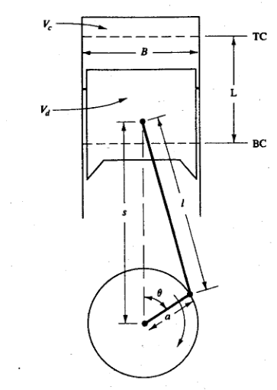

Figure 3.1 Geometry of cylinder, piston, connecting rod, and crankshaft [18].

*B = bore, L = stroke, l = connecting rod length, a = crank radius*, .

The modeling of our engine starts with basic geometrical relationships and the parameters that characterize engine operations.

3.1

= swept volume or displacement volume.

= clearance volume.

3.2

3.3

3.4

Piston Displacement

The displacement of the piston is a function of the angle of crank rotation and is given by:

Where:

-------------------------- 3.7

Piston Velocity

Piston speed is also plotted against the angle of crank rotation for a given value .

During the displacement of the piston, its velocity varies and if the angular rotation is kept constant, it depends only on the angle of rotation of the crank and the relation

Piston Speed 3.8

Maximum velocity of the piston 3.9

Piston Acceleration: The acceleration of the piston is given by

Maximum acceleration

Maximum acceleration is attained when

### Engine Component Design

The internal combustion engine is one of the most complex machines with several components working harmoniously together to create power that is delivered to other contrivances. In this project, it is evident that among various components of the engine, the ones responsible for power production and fuel/air delivery system are faulty and need restoration to their original or optimal performance.

Inertia forces in an engine depend on the values and relations of the aforementioned parameters and formulae in section 3.3.1. Machine design element or engine component design aimed at determining stresses and strains occurring during engine operations such as idling, part-load, and full throttle load. Although in this project we will not go into the details of materials selection, inertia forces of reciprocating and rotating masses, thermal loads, and design requirements for each component considerations such as the forces of gas pressure and the dynamics of air-fuel delivery system will be minimally considered.

* + 1. Piston

The piston provides a uniform air-tight volume around the space inside the cylinders and transmission of forces of gas pressure, with high efficiency and less losses to the crank mechanism as its main function.

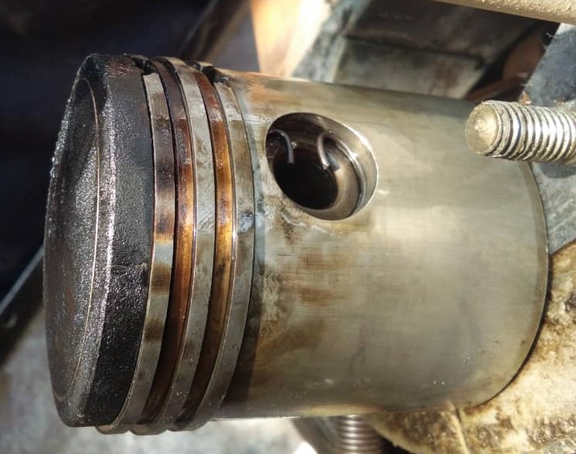

Figure 3.2 Combustion Piston with three Identical Rings.

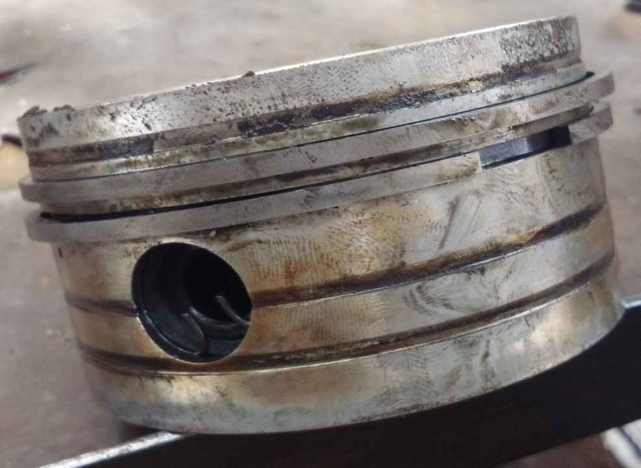

Figure 3.3 Air Pressurizing Piston for Pneumatic System.

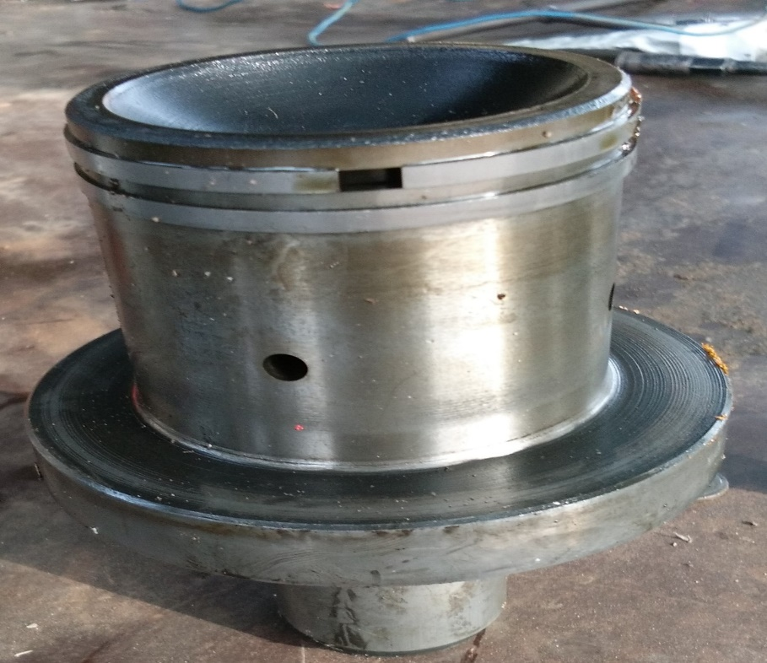

Figure 3.4 Damper to reduce vibration.

In the case of this particular machine, it has three different types of pistons two are controlled by the same crankshaft. The piston of Figure 11 is the major piston designed for the combustion of gasses and transmission of torque to the crankshaft, while the piston of Figure 12 is connected radially and opposite to the combustion piston on the same crankshaft and functions as a pressurizer of the air within its clearance volume.

The piston is a highly complex component of the internal combustion engine both in construction and the technology for material selections. The main tendency in improving the design of pistons today is the reduction of mass and dimensions, increase in wear resistance, and as well reduction in the coefficient of linear expansivity [19]. `

* + 1. Piston Rings

The piston rings operate synonymously with the piston under variable load conditions and extremely high-temperature ranges from the combustion of gasses in the combustion chamber. In so much literature, it is reported that the piston rings performed three functions:

* Seal the space over the piston to maximize the utilization of air-fuel energy during and after combustion.
* Conduct excess heat from the piston to the cylinder walls for cooling the piston in other to reduce thermal stresses.
* Create an avenue for uniform distribution of oil over the surface of the cylinder and prevention of oil from entering the combustion chamber during the four-stroke cycle of combustion most especially compression stroke and the power stroke.

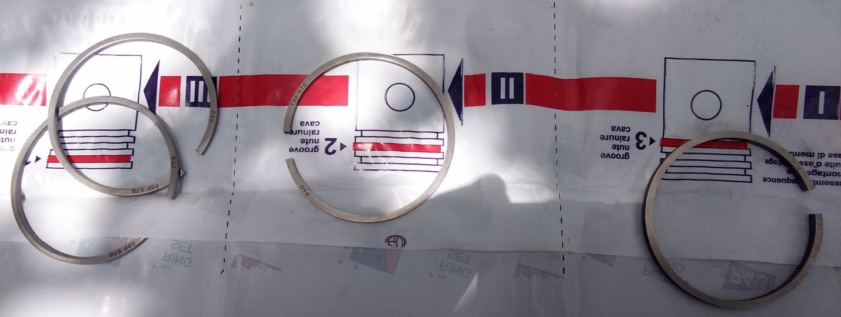

Figure 3.5 Piston Rings.

### Engine Fuel and Air System

In a two-stroke engine, the fuel-air mixture plays a crucial role in the combustion process, as it directly impacts engine performance, power output, and emissions. Unlike four-stroke engines, two-stroke engines complete the entire combustion cycle in just two strokes of the piston: the compression stroke and the power stroke.

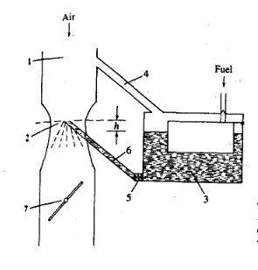 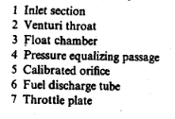

Figure 3.6 Schematic diagram of a Carburetor.

Carburetor: the preparation of atomized and vaporized combustible homogeneous mixture of liquid fuel with air in correct proportion before ignition is called carburation [20]. Transforming the gasoline from a liquid into a combustible form requires the liquid fuel to enter the carburetor, where it is sprayed into incoming air and atomized. The atomized mixture then moves into the intake manifold where it is changed into vapor.



Figure 3.7 Carburetor.

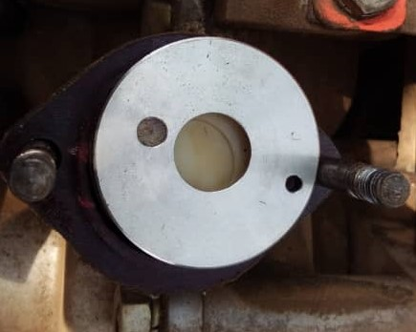

Figure 3.8 circular disc Nozzle.

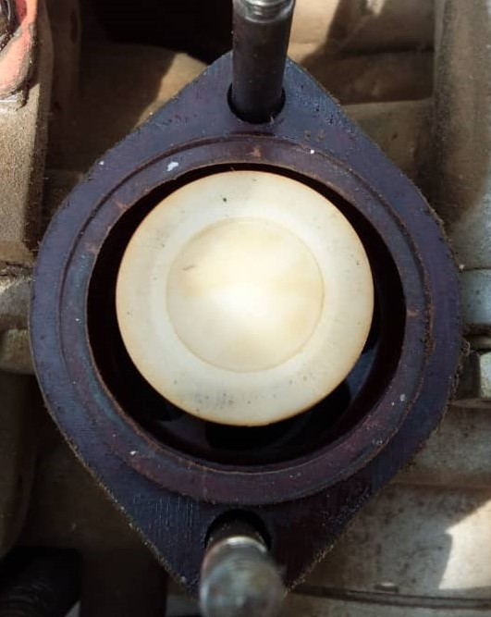

Figure 3.9 Intake Manifold

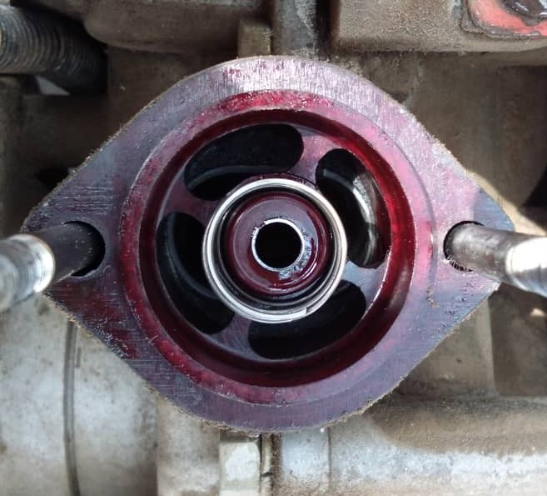

Figure 3.10 Intake Manifold.

For vaporization to take place the incoming fuel must be hot enough to boil. Due to the lower pressure within the intake manifold compared to atmospheric pressure, the gasoline's boiling point decreases upon entering the manifold. The intake manifold's heat, along with heat absorbed from surrounding air particles, initiates the vaporization process which eventually helps to raise the temperature of the manifold.

Airflow analysis in carburetor.

Bernoulli’s energy equation is used to analyze fluid flow in a carburetor.

Given that is negligible small the ideal velocity of air at the throat is

While the actual velocity accounting for friction losses is

--- 3.14.

Flow differs between the throat and venturi, so for the venturi a more accurate equation for airflow is

The mass flow rate of a gas through a Row restriction to the upstream stagnation pressure

and temperature and the pressure at the throat for the venturi becomes:

.

Fuel flow through the Orifice: The fuel been a liquid is essentially incompressible, therefore the flow rate of fuel is given by

Where

In evaluating the performance of an internal combustion engine, the combustion efficiency is a major candidate that dictates how efficiently our machine is running, therefore the carburation performance is given by

## Corrective Maintenance

Maintainability represents the intrinsic quality of an item, indicating its ability to be either preserved in its current state or restored to a predefined condition when maintenance actions are undertaken. In essence, it serves as a measure of the efficiency and expeditiousness with which a system can be reestablished to full operational functionality in the event of a malfunction or breakdown. The overarching aim of maintainability is to ensure that the system can be sustainably managed with minimal time and financial investment, all the while conserving a judicious allocation of resources. Mathematically maintainability is expressed as [18]:

Where is the maintainability function, is time and is the repair time probability density function.

Corrective maintenance, often referred to as "breakdown maintenance" or "repair maintenance," is a type of maintenance strategy focused on addressing and rectifying equipment or system failures, defects, or malfunctions after they have occurred. In other words, corrective maintenance is carried out in response to an unexpected failure or issue, with the primary goal being to restore the system to its operational state as quickly as possible. This type of maintenance is typically unplanned and reactive, rather than pre-scheduled.

### Modeling Corrective Maintenance

Modeling involves creating a mathematical or statistical representation of the maintenance process to analyze and optimize. The model can be continually refined and updated as more data becomes available, allowing for more accurate predictions and cost-effective maintenance strategies.

* **Mean Time to Repair (MTTR):** MTTR measures the average time it takes to restore an internal combustion engine-powered pneumatic drill to operational status after a failure. It can be calculated as follows:

Where "Repair Times" is the sum of the time taken to repair the drill after each failure, and "Number of Failures" is the total number of failures within a specified time period.

* **Availability (A):** Availability is a crucial metric that indicates the proportion of time the pneumatic drill is available for use, considering both its operational time and downtime for corrective maintenance. Availability can be calculated using this formula: .

Here, MTBF (Mean Time Between Failures) represents the average time the drill operates without encountering a failure, while MTTR (Mean Time to Repair) is the average time it takes to restore the drill after a failure.

* **Failure Rate (λ):** The failure rate measures the rate at which failures occur within the internal combustion engine-powered pneumatic drill. It can be calculated as:

where is the reliability at time t, is cumulative failure distribution function and is failure probability density function.

These mathematical representations can help in assessing the effectiveness of corrective maintenance strategies for internal combustion engine-powered pneumatic drills. They enable engineers and maintenance professionals to make informed decisions about maintenance schedules, costs, and system reliability to ensure efficient and reliable drill performance.

* **Repair Time Distribution (T):** This represents the probability distribution of repair times. In real-world situations, repair times can vary widely. Common distributions used include the exponential distribution, Weibull distribution, or empirical data-based distributions.

The Exponential Distribution:

The probability density function (PDF) for exponential distribution is given by:

Where:

(lambda) is the rate parameter. It represents the average number of events per unit time.

The cumulative distribution function (CDF) of the exponential distribution is:

The Weibull Distribution:

The probability density function of the Weibull distribution is given by:

Where:

(lambda) is the scale parameter. It represents the characteristic time until the first event.

(kappa) is the shape parameter. It represents the shape of the distribution.

If *k* < 1, the failure rate decreases over time (infant mortality); if *k* = 1, the failure rate is constant over time; if *k* > 1, the failure rate increases over time.

* **Failure Mode and Effects Analysis (FMEA):** FMEA is a qualitative and quantitative approach to identify and prioritize failure modes, their causes, and consequences. It assigns a risk priority number (RPN) to each failure mode, helping in decision-making for corrective maintenance.

### Modeling Noise and Vibration

Vibration modeling for internal combustion engine-powered pneumatic drills involves predicting and quantifying the vibration levels generated by the drill during its operation. This modeling can help in optimizing the design of the drill, assessing the impact of vibration on operators, and implementing vibration reduction strategies.

1. **. Key Parameters:**

* **Drill Characteristics:** Information about the internal combustion engine-powered pneumatic drill, including its engine specifications, drill bit size, rotation speed, and other relevant parameters forms the baseline for the analysis.
* **Material and Workpiece Properties:** The material the drill will be used on is paramount in achieving success, as different materials can affect vibration levels.

1. **Vibration Sources:**

* **Engine:** The internal combustion engine is a primary source of vibration. The engine's specifications, such as its displacement, power, and balance, play a significant role.
* **Rotating Components:** Identify components within the drill that rotate, such as the drill bit, drill gear, plunger/piston, and engine crankshaft, as they can introduce vibration.

1. **Characteristics of Vibration Sources** [19]**:**

* **Vibration Spectra:** Vibration spectra are graphical representations of a vibration source's frequency content, which provide insights into the different frequency components and their amplitudes. These spectra are essential for understanding and characterizing the vibration generated by a source. In the context of internal combustion engine-powered pneumatic drills, vibration spectra can help identify the primary sources of vibration and their associated frequencies [20].
* **Frequency Response Functions:** Frequency response determines how these vibrations are transmitted through the drill's structure to the handles and the operator's hand. This involves the drill's mechanical characteristics, such as its mass, stiffness, and damping [21, 22].

1. **Coupling and Propagation:**

* Consider how vibrations are coupled from the engine and rotating components into the drill's structure. The drill's mechanical design can significantly affect this coupling.
* Predict how vibrations propagate through the drill's handles and into the operator's hand. This is influenced by the design of the handles, the type of grip used, and the operator's posture.

1. **Validation and Calibration:**

Validation and calibration in the context of internal combustion engine-powered pneumatic drills refer to the process of ensuring that the models, measurements, and predictions related to the drill's performance, including vibration, align with real-world data and observations.

1. **Optimization and Mitigation:**

* If the predicted vibration levels are above acceptable limits, consider making design changes to reduce vibration. This might involve modifying the drill's structure, using anti-vibration components, or implementing maintenance and alignment procedures [23].

## **Data Collection**

### Review

A thorough literature review is conducted to gather relevant information on internal combustion engine-powered pneumatic drills, drilling technologies, fault tree analysis, and related studies on drilling system failures. Various academic databases, scientific journals, conference proceedings, and books are utilized to source credible and up-to-date literature.

### **Case Studies and Observations**

Real-world case studies are carried out in collaboration with mining and construction companies that employ various types of drilling operations. These case studies involve on-site observations of the drilling processes, data collection on drilling performance metrics, and interviews with drill operators and maintenance personnel. The information gathered from the case studies will reveal valuable insights into the actual performance and operational challenges faced by the drilling operators.

## **Analytical Approach**

### **Fault Tree Analysis (FTA)**

Fault Tree Analysis (FTA) is employed as the primary analytical tool for this study. FTA is a top-down deductive failure analysis method that systematically traces potential failure modes back to their root causes. The fault tree is constructed based on the identified failure events and their logical relationships. The top-level event represents the undesired system failure, and the lower-level events represent the component failures or conditions leading to the top-level event. Quantitative or qualitative probabilities are assigned to each event to estimate the overall system failure probability. The analysis enables the identification of critical failure paths and weak points in the drilling systems, facilitating the formulation of appropriate risk mitigation strategies.

### **Fault Tree Analysis Design**

Fault Tree Design (FTD) is a systematic and graphical method used to analyze and understand the various potential causes of a specific undesired event or system failure. FTA helps identify the primary and contributing factors that can lead to the undesired event symbolically. The figure below shows some symbols used in the FTA [24].

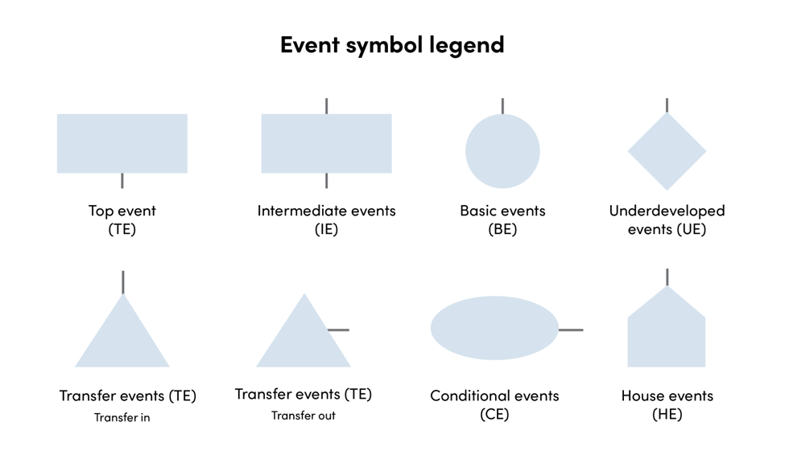Figure 3.11 Event Symbol Legend [24]

Here's an overview of how FTA is performed:

* **Select the Undesired Event:** Begin by clearly defining the undesired event or failure that you want to analyze. This could be a system failure, a safety incident, or any event that you want to understand in detail.
* **Identify the Top Event:** The top event is the specific undesired event you've chosen. It is placed at the top of the fault tree diagram.
* **Determine Primary Causes:** Identify the immediate causes or basic events that directly contribute to the top event. These are usually placed just below the top event and are connected to it with logical gates.
* **Identify Contributing Causes:** Identify any intermediate events or contributing causes that lead to the primary causes. These are placed below the primary causes and connected with logical gates as well.
* **Use Logical Gates:** Logical gates (AND, OR) are used to depict the relationships between events.
  + **AND Gate:** Represents that all its input events must occur for the output event to occur. It implies an "and" relationship.
  + **OR Gate:** Represents that any one of its input events can lead to the output event. It implies an "or" relationship.
* **Quantify Probabilities:** Assign probabilities or failure rates to each event, if possible, to quantify the likelihood of their occurrence. This helps in assessing the overall risk.
* **Construct the Diagram:** Create a visual diagram that shows the hierarchy of events, with the top event at the top and the contributing events below it. Use logical gates to depict relationships. Software tools are often used to create FTA diagrams, which can help in analysis and documentation.
* **Analyze the Fault Tree:** Once the fault tree is constructed, you can use it to systematically evaluate the causes of the top event. You can calculate the overall probability of the top event occurring based on the probabilities assigned to the lower-level events. This analysis can help identify critical paths and root causes.
* **Mitigate Risks:** Based on the analysis, you can develop strategies to mitigate the risks associated with the undesired event. This might involve strengthening components, implementing safety measures, or making changes to the system's design.
* **Documentation and Reporting:** Document the fault tree, including the probabilities, and the results of the analysis. Share the findings with relevant stakeholders.

**Gate Symbols**

Gates serve as representations of the different pathways through which failures may manifest within an asset or system. On occasion, a singular occurrence can precipitate a top-level failure, which may also be termed a catastrophic failure. Alternatively, a culmination of distinct events can collectively lead to the occurrence of a top-level failure event. The following outlines the various types of gates employed in Fault Tree Analysis (FTA)

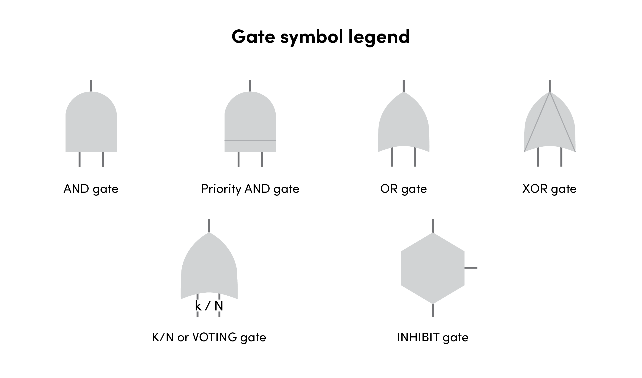

Figure 3.12 Gate Symbols [24].

* AND gate: This type of gate is connected to output events. The events only occur if the input events to the gate occur.
* Priority AND gate: This gate occurs if all the input events happen in a specific order.
* OR gate: This type of gate may have one or more inputs, and an output event will occur if one or more of the input events happen.
* XOR gate: This gate is slightly less common. An output happens only if one input element occurs.
* k/N or VOTING gate: This gate is similar to the OR gate visually. There will be a number of input events ‘N’ and one output event ‘k.’ The output event occurs when the number of input events occurs. The exact number of inputs needs to be met to trigger this gate.
* INHIBIT gate: This type of gate will have an output event when all input and conditional events occur.

The below table shows some sample algebraic truth tables for the logical connective gate symbols.

Table 3.1 Truth Table.

|  |  |  |  |  |  |  |
| --- | --- | --- | --- | --- | --- | --- |
| P | Q | P and Q | P or Q | not P | not Q | P xor Q |
| 0 | 0 | 0 | 0 | 1 | 1 | 0 |
| 0 | 1 | 0 | 1 | 1 | 0 | 1 |
| 1 | 0 | 0 | 1 | 0 | 1 | 1 |
| 1 | 1 | 1 | 1 | 0 | 0 | 0 |

Starting System Failure

Power Reduction Failure

Drilling System Failure

1

2

3

Figure 3.13 General System Failure, complete diagram in Appendix A.

### **Probability Theory**

Probability is the degree of belief or measure of uncertainty that a particular event will happen. In artificial intelligence, we deal with a wide spectrum of probability theories such as conditional probability, joint probability, Inclusion-Exclusion principle, and Marginalization.

Conditional Probability: this is the degree of proposition given some evidence that has already been revealed [25].

is the probability of outcomes or proposition

.

### Joint Probability: Joint probability refers to the probability of two or more events occurring simultaneously. If we have events A and B, the joint probability of both A and B happening is denoted as .

is the conditional probability of B given that event A has occurred.

Inclusion-Exclusion Principle: The inclusion-exclusion principle is a counting technique used to calculate the size of the union of multiple sets. It states that to find the total number of elements in the union of two or more sets, we need to add the sizes of the individual sets and then subtract the sizes of their intersections.

Internal-combustion engine power-pneumatic drill is one complex machine that is coupled by three distinct machines as one, that is the internal combustion engine which is a two-stroke engine, the air compressor which serves as the pneumatic system pumping air, and the drilling machine housing the drill bit. Random faults can easily arise which can stop the functionality of the whole machine; therefore, such events bring about a random probability of component failure. Statistically random faults create a random distribution of variables in our case faults which we must figure out in other to isolate the non-trivial faults or events. The above-mentioned phenomena lead us to Baye’s rule.

Bayes' Theorem, often referred to as Bayes' Rule or Bayes' Law, is a fundamental concept in probability theory and statistics. It is used to update or revise the probability for a hypothesis or event based on new evidence or information. In essence, Bayes' Theorem quantifies how our belief or confidence in the occurrence of an event should change when new information becomes available.

In words, Bayes' Theorem states that the probability of event A occurring, given that event B has occurred, is proportional to the probability of event B occurring given that event A has occurred, multiplied by the prior probability of event A, and then divided by the prior probability of event B.

Bayes' Theorem is particularly useful in situations involving uncertainty and the need to update beliefs as new evidence becomes available. It is widely used in various fields, including machine learning, Bayesian statistics, medical diagnosis, natural language processing, and more. Bayesian inference is a powerful framework for making predictions and decisions based on probabilities and evidence.

Mathematically, Bayes' Theorem is expressed as follows:

Where:

* is the conditional probability of an event (a) occurring given that event (b) has occurred.

is the conditional probability of an event (b) occurring given that event (a) has occurred.

* is the prior probability of an event (a) (the initial probability of A occurring, based on previous information).
* is the prior probability of event B (the initial probability of B occurring, based on previous information).
* The failure probability of an event either top event or intermediate event can be estimated using:
* For OR gates:
* For AND gates:
  + - 1. Bayesian Network

A Bayesian Network is a data structure that represents the dependencies among random variables. The network leverages the implementation of decision trees and random forests as a well-known graphical model to create a causal effect, a relationship between key factors (causes) and outcomes of a system [29].

Characteristics of the Bayesian network include:

* It is a Directed Acyclic Graph (DAG)
* Each node represents a random variable
* Arrow from X to Y indicate X to be a parent of Y
* Each node X has a probability distribution that is the probability of X given the Parent of X.
  + - 1. Inference

Statistical inference involves drawing conclusions about a population based on a sample of data. In machine learning and AI, inference refers to making predictions or decisions based on learned patterns in data. Models are trained on labeled datasets and then used to infer the outcomes of new, unseen data.

The method of inference by Enumeration will be applied in these projects.

* Query X: variable for which to compute the distribution
* Evidence Variable E: Observed variable for event e
* Hidden Variables Y: Non-evidence, non-query variable
* Goal: Calculate the probability of X given some event e occurred.

### **Fault Tree Repair Strategy**

Performing refurbishing or repair of the Internal Combustion System Powered Pneumatic Drill based on Fault Tree Analysis (FTA) involves identifying the root causes of the system's non-functionality as identified by the FTA, and then implementing corrective actions to address those root causes.

The following methodology will be used in this project:

* **Review of the FTA Results**: A fault tree diagram and associate analysis will be performed to identify the primary and contributing causes of the system failure.
* **Critical Path Analysis**: The critical components or subsystems that are contributing significantly to the failure of the machine will be pinpointed for further analysis.
* **Prioritize Issues**: Component failure identified will be given priority attention based on their importance and contribution to the system failure.
* **Corrective Action Development**: For each identified cause, specific corrective actions shall be implemented. These actions could include repairing or replacing faulty components, improving maintenance procedures, or enhancing system design.
* **Documentation and Data Collection (Log File)**: Document the entire refurbishing process, including the actions taken, outcomes, and any lessons learned. This documentation is valuable for future troubleshooting, maintenance history logs, and improvements.

1. CHAPTER FOUR
   1. **Data Analysis and Results**

This chapter presents the research design and methodology employed to evaluate the performance of internal combustion engine-powered pneumatic drills using Fault Tree Analysis (FTA). It outlines the systematic approach undertaken to achieve the research objectives, including data collection, analytical techniques, and modeling methodologies.

* 1. **Data Collection and Bayesian Network Construction**

The research design for this study is exploratory and analytical in nature, aiming to gain insights into the performance characteristics and failure modes of internal combustion engine-powered pneumatic drills. This approach combines qualitative and quantitative methods to comprehensively assess the drilling systems' safety, reliability, and efficiency through refurbishing the machine. The exploratory aspect of the research involves a thorough literature review to understand the current state of knowledge related to drilling technologies, internal combustion engines, fault tree analysis, and drilling system failures. This review provides the foundation for identifying research gaps. The analytical component of the research involves the application of Fault Tree Analysis (FTA) as the primary method for analyzing the root causes of system failures. FTA is a top-down deductive approach that systematically traces potential failure modes back to their underlying causes. By constructing fault tree diagrams and assigning probabilities to each event, this method enables the identification of critical failure paths and weak points in the drilling systems.

The top event or Failure Probability of the system is estimated from the Basic Events or combinations of intermediate events. The basic events are the main nodes of the Bayesian network which depicts the probability of failure of each component characteristic.

Among the exploratory aspects of this thesis was utilizing expert opinion to generate ratings which are eventually converted to probabilities for the basic events in our Bayesian Network.

The complete fault tree of the system is given in Appendix A while Appendix B is the rating according to each expert, although the Engineers and Technicians are given more weight to their rating mainly because of their knowledge background, and practical experience in maintaining such machines over a long period. The Engineer has a weight factor of 3 while the Technician has a weight factor of 2. The table below depicts ratings and weight for each component failure for all the experts. More details of the rating pattern are given in the Appendix.

Table 4.1. Failure rating due to Non-Starting of Engine

|  |  |  |  |  |
| --- | --- | --- | --- | --- |
| Component | Engineer | Technician | User | AI |
| Spark Plug | 99 | 70 | 30 | 31 |
| Ignition Coil | 90 | 58 | 30 | 31 |
| Carburetor | 117 | 86 | 40 | 42 |
| Filter | 81 | 56 | 29 | 26 |
| Crankshaft | 96 | 58 | 30 | 31 |
| Piston | 111 | 76 | 35 | 36 |
| Piston Rings | 111 | 76 | 37 | 38 |
| Connecting Rod | 96 | 66 | 30 | 32 |
| Timing | 81 | 56 | 27 | 27 |
| Valve | 105 | 74 | 34 | 33 |
| ***TOTAL*** | ***987*** | ***676*** | ***322*** | ***326*** |



Table 4.2. Failure ratings due to Power-Loss and Misfiring

|  |  |  |  |  |
| --- | --- | --- | --- | --- |
| Components | Engineer | Technician | User | A I |
| Carburetor | 132 | 88 | 43 | 45 |
| Piston Rings | 123 | 84 | 43 | 42 |
| Spark Plug | 102 | 64 | 34 | 34 |
| Ignition Coil | 93 | 64 | 31 | 31 |
| Air Filter | 78 | 54 | 26 | 25 |
| Top Gasket | 93 | 64 | 31 | 32 |
| Crank-Bearings | 102 | 66 | 34 | 33 |
| Fuel Lines | 123 | 84 | 41 | 42 |
| Oil Seals | 102 | 66 | 34 | 33 |
| Exhaust Manifold | 102 | 70 | 34 | 35 |
| Intake Manifold | 108 | 74 | 36 | 36 |
| Valve | 93 | 64 | 31 | 33 |
| ***TOTAL*** | ***1251*** | ***824*** | ***418*** | ***421*** |

The probabilities of failure of the Basic Events (BEs) were computed from the above ratings, the rating scheme employs a combination of expert views mainly because of differences in intellectual attributes, skill, available information, educational background, and long-term experience.

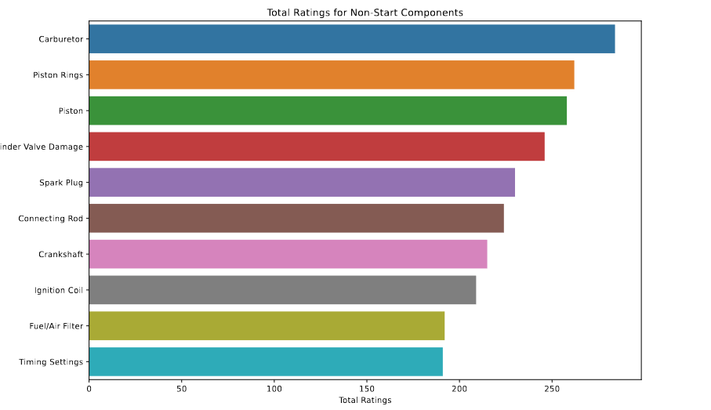

Figure 4.1 Non-Starting Engine Component Failure Ratings.

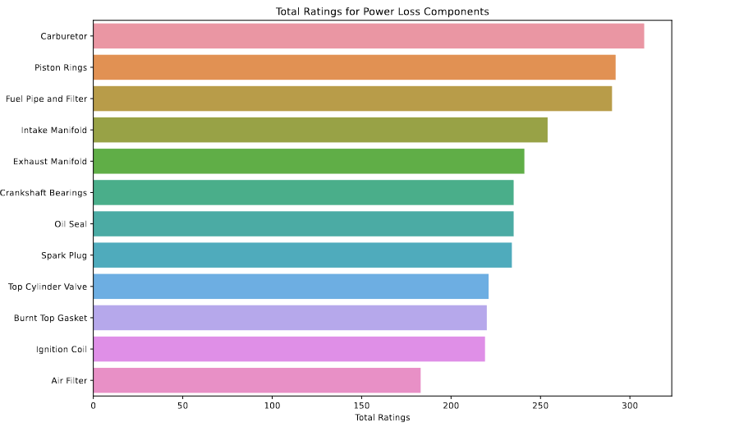

Figure 4.2 Power-Loss Engine Component Failure Ratings.

For a non-starting engine and reduced power operation, the carburetor failure has the highest vote as the major culprit for both failures while timing settings are the least cause of the engine not starting as compared to the Air filter which is least responsible for power reduction in misfiring engine. The bar chart at a glance provides the rating of each engine component and its likelihood of contributing to a particular failure. Furthermore, a graph of Heatmap shows the intensity of the relationship between experts and the components below.

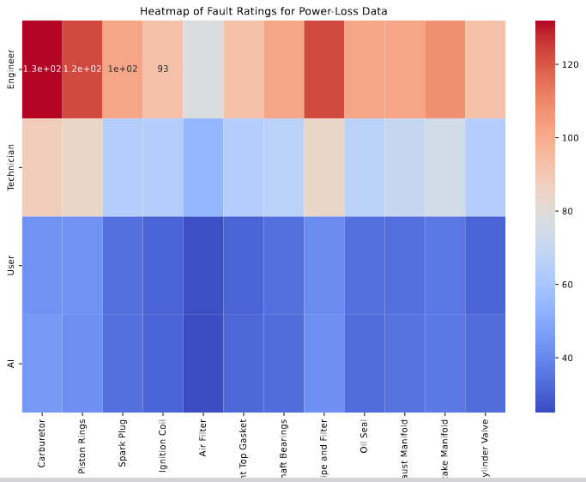

Figure 4.3 Heat-Map for Non-Start Engine Component Failure Rating

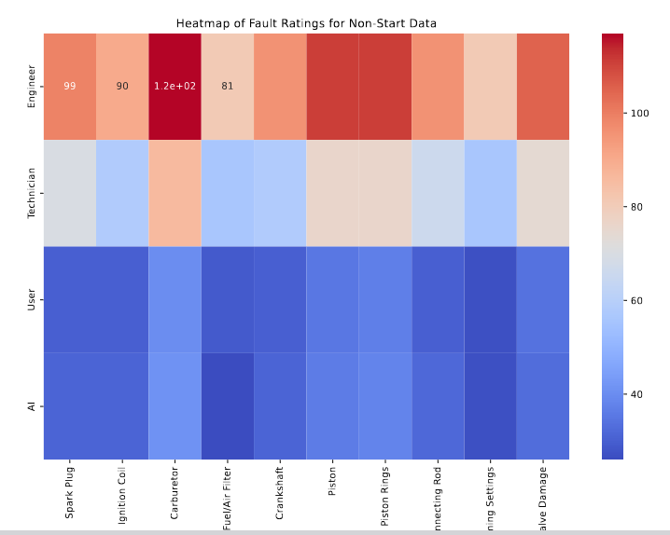

Figure 4.4 Heat-Map for Power-Loss Engine Component Rating

Both heatmaps show the pairwise correlations between the ratings given by different experts for non-start faults and Power-Loss or Misfiring faults. Each cell in the heatmap represents a correlation coefficient, indicating the strength and direction of the linear relationship between two variables. Positive correlations are shown in warm colors (reds), and negative correlations in cool colors (blues). It helps identify which expert ratings are most similar or dissimilar to each other.

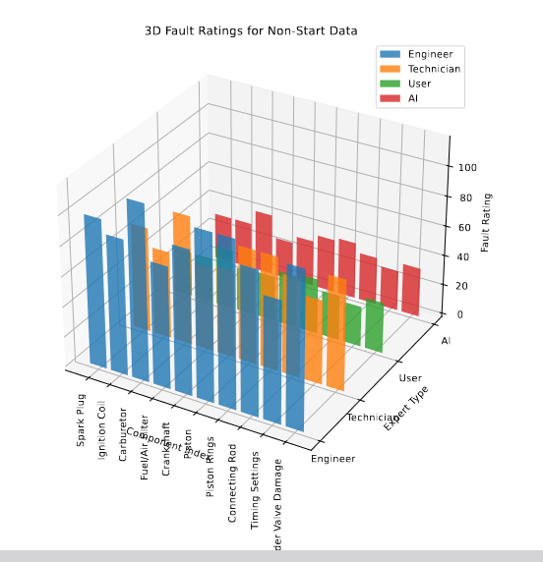

Figure 4.5 3D plot

Table 4.3 Probability of Failure Non-Start Engine Components

| **Component** | **Probability** |
| --- | --- |
| Spark Plug | 0.1003 |
| Ignition Coil | 0.0898 |
| Carburetor | 0.1248 |
| Fuel/Air Filter | 0.0836 |
| Crankshaft | 0.0974 |
| Piston | 0.1106 |
| Piston Rings | 0.1106 |
| Connecting Rod | 0.0944 |
| Timing Settings | 0.0836 |
| Cylinder Valve Damage | 0.1049 |

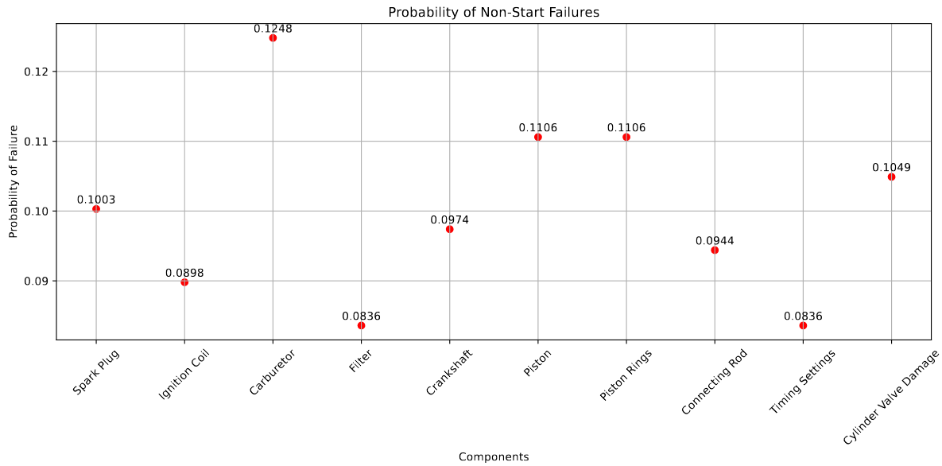

Figure 4.6 Scatter Plot for Non-Starting Engine Probability Failure

Table 4.4 Probability of Failure for Power-Loss Engine Component

| **Component** | **Probability** |
| --- | --- |
| Carburetor | 0.0875 |
| Piston Rings | 0.0828 |
| Spark Plug | 0.0662 |
| Ignition Coil | 0.0593 |
| Air Filter | 0.0518 |
| Burnt Top Gasket | 0.0593 |
| Crankshaft Bearings | 0.0678 |
| Fuel Pipe and Filter | 0.0828 |
| Oil Seal | 0.0678 |
| Exhaust Manifold | 0.0678 |
| Intake Manifold | 0.0717 |
| Top Cylinder Valve | 0.0593 |

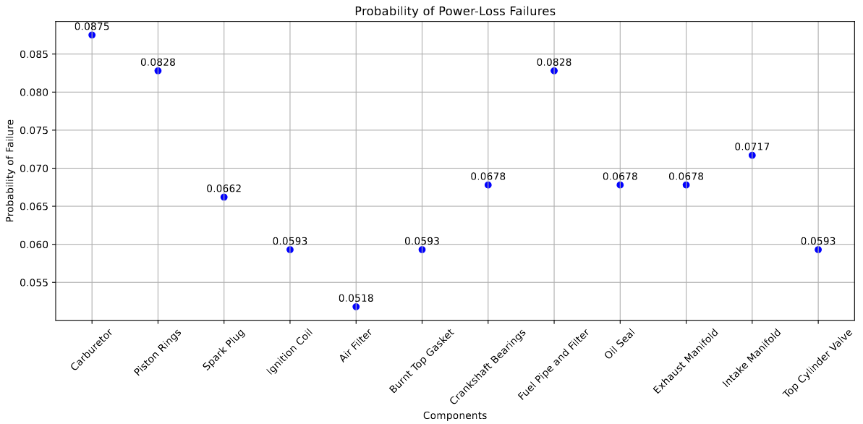

Figure 4.7 Scatter Plot for Power-Loss Engine Probability Failure

Tables 4.3 and 4.4 contain the probabilities of failure for each component, the probabilities are critical components (F5, F6, F7, F8, F9, F10, F11, F12, F13) estimated from the relation of expert rating for each component. Afterward, the critical components are named (F2, F3, F5, F6, F7, F8, F9, F10, F11, F12, F13) which identifies a critical pathway to failure known as Intermediate Event (IE).

## **Minimum Cut-Set**

The minimum cut-sets represent the smallest combination of component failures that would result in the system failure (top event). Using the Pomegranate library, the following minimum cut-sets were identified:

* **Cut-Set 1:** {F2, F3, F4}
* **Cut-Set 2**: {F5, F9, F11}
* **Cut-Set 3**: {F6, F12, F13}
* **Cut-Set 4**: {F7, F8}
* **Cut-Set 5**: {F10}

These cut-sets highlight the critical components whose failures directly impact the overall system performance.

## Reliability and Availability

The reliability and availability of the top event (F1) and intermediate events were calculated using the Bayesian Network model. The reliability (R) and availability (A) for each event were determined as follows:

* **Reliability (R)**: The probability that the component or system performs its intended function without failure over a specified period.
* **Availability (A)**: The probability that the component or system is operational and available for use when required.

The following results were obtained:

Table 4.5 Result of the Analysis

| **Event** | **Failure Probability** | **Reliability** | **Unavailability** | **Availability** |
| --- | --- | --- | --- | --- |
| F1 | 0.3248 | 0.6752 | 0.3248 | 0.6752 |
| F2 | 0.0500 | 0.9500 | 0.0500 | 0.9500 |
| F3 | 0.0300 | 0.9700 | 0.0300 | 0.9700 |
| F4 | 0.0700 | 0.9300 | 0.0700 | 0.9300 |
| F5 | 0.1000 | 0.9000 | 0.1000 | 0.9000 |
| F6 | 0.0400 | 0.9600 | 0.0400 | 0.9600 |
| F7 | 0.0200 | 0.9800 | 0.0200 | 0.9800 |
| F8 | 0.0600 | 0.9400 | 0.0600 | 0.9400 |
| F9 | 0.0800 | 0.9200 | 0.0800 | 0.9200 |
| F10 | 0.0500 | 0.9500 | 0.0500 | 0.9500 |
| F11 | 0.0900 | 0.9100 | 0.0900 | 0.9100 |
| F12 | 0.0100 | 0.9900 | 0.0100 | 0.9900 |
| F13 | 0.0300 | 0.9700 | 0.0300 | 0.9700 |

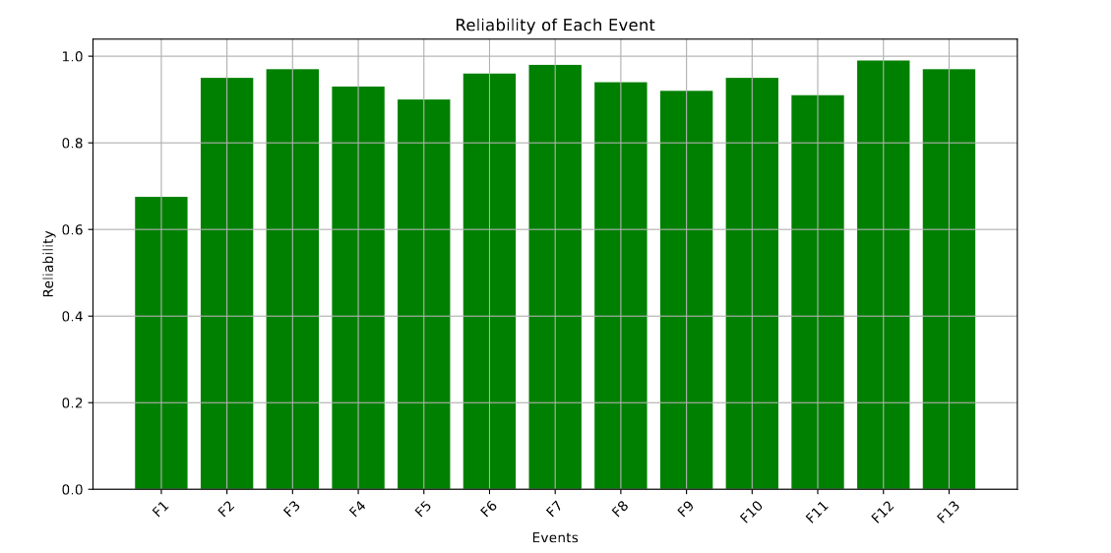

Figure 4.8 Reliability of the Machine

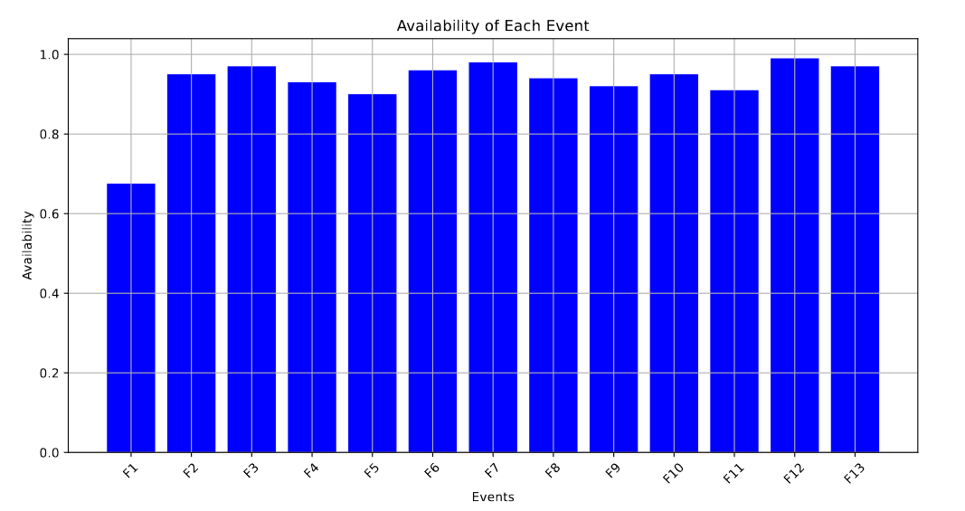

Figure 4.9 Availability of the Machine

**Reliability**:

* The plot shows the probability that each event will remain operational over the 5 years.
* Events with high reliability (e.g., F12 and F7) are less likely to fail, indicating they are robust components.

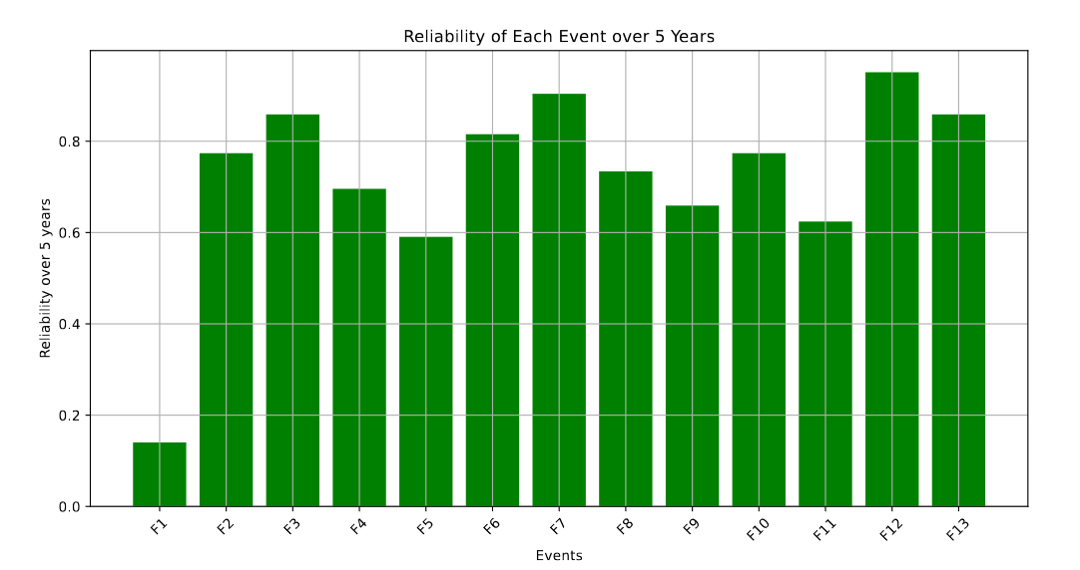

Figure 4.10 Five Years Prediction (Reliability)

## Failure Probability and Unavailability

The failure probability (Q) and unavailability (U) for each event were also calculated. The failure probability indicates the likelihood of failure occurring, while unavailability represents the proportion of time the component or system is not operational.

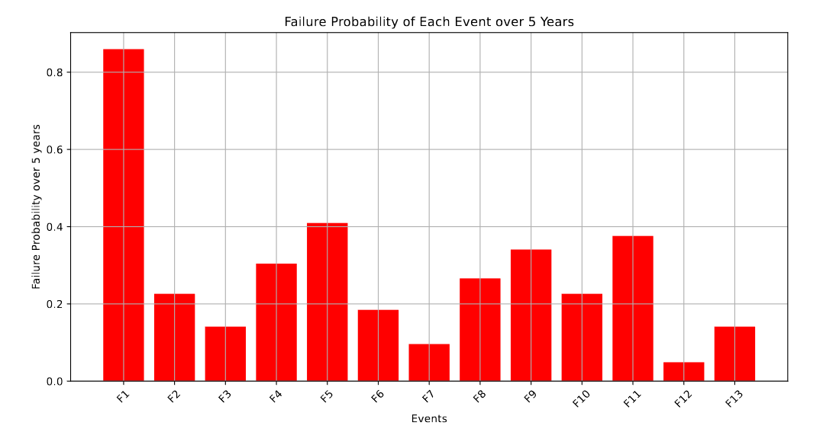

Figure 4.12 Five Years Prediction (Failure Probability)

**Unavailability and Failure Probability**:

* This plot represents the probability that each event will be non-operational over the 5 years.
* Events with high unavailability (e.g., F5 and F11) are more likely to fail, indicating they are critical components that need more attention and which eventually lead to the failure of the machine (F1).

## Discussion

The results indicate that the top event (F1) has a low reliability of approximately 0.18 over five years, suggesting the system is not robust. However, certain intermediate events, such as F5, F9, and F11, also exhibit lower reliability and higher failure probabilities, highlighting potential weak points in the system.

* **High Reliability Components**: Events like F7 and F12 show high reliability, making them less likely to contribute to system failure.
* **Low-Reliability Components**: Events such as F5, F9, and F11 demonstrate higher failure probabilities, necessitating closer inspection and potential redesign or more frequent maintenance to mitigate risks.

By identifying these critical components, we can focus on improving the reliability of the entire system, ensuring better performance and reduced downtime.

## Operational Parameters

Operational parameters such as sound level, vibration, fuel-to-oil mixture, drill speed, and rotating speeds were monitored to assess their influence on the performance and potential failure of the machine.

Table 4.6 Operational Parameter

| **Parameter** | **Measured Value** | **Threshold Value** |
| --- | --- | --- |
| Sound Level | ≥85 dB | ≤85 dB |
| Vibration | ≥6.9 mm/sec/sec | 8.3 mm/sec/sec |
| Fuel-to-Oil Mixture | 12:1 | Optimal at 15:1 |
| Drill Speed | ≥250 mm/min | ≥250 mm/min |
| Engine Rotating Speed | ≥2450 r/min | ≥2450 r/min |
| Drill Rod Rotating Speed | 200 r/min | 200 r/min |
| Flue Gas Analyzer | 346ppm | 4035ppm |

* **Sound Level**: Excessive noise indicates potential issues with the exhaust system or engine components.

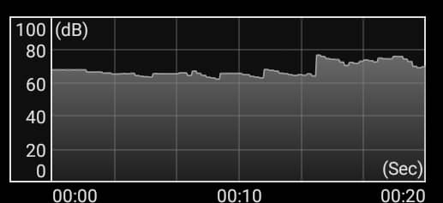

* **Vibration**: High vibration levels may be attributed to imbalances in the rotating components, suggesting the need for alignment and balancing. Moreover, the vibrometer is not very reliable due to an error that was noticed in its calibration.
* **Fuel-to-Oil Mixture**: An improper mixture can lead to engine inefficiency and increased wear, emphasizing the need for precise fuel management. When a proper mixture of fuel to oil is maintained, the emission is within the range of 346ppm to 650ppm while a rich mixture is characterized by visible emission (white smoke) in the range of 3000ppm to 6087ppm.
* **Drill Speed and Rotating Speeds**: These parameters directly affect the machine's performance and the quality of the drilling operation. Although, a too-high speed can easily cause disaster for the operator a moderate speed is always preferable.

# CHAPTER FIVE

## Conclusion

The performance evaluation of the internal combustion engine-powered pneumatic drilling machine using Fault Tree Analysis (FTA) has provided valuable insights into the critical components and their impact on the system's reliability and availability. The Bayesian Network model developed using the Pomegranate library in Python effectively identified the minimum cut-sets and calculated the reliability, availability, failure probability, and unavailability of both the top event and intermediate events.

Key findings include:

* **Pomegranate**: Is quite an interesting statistical computing environment for the implementation of FTA-Bayesian Network structure of problems in Python Programming Language.
* **Critical Components**: Piston Rings, Ignition Coil, Carburetor, and other major components significantly impact the system's reliability.
* **Reliability and Availability**: The system exhibits a reliability of 0.6752, indicating its robustness under normal operating conditions but with time there is serious degradation of the overall machine efficiency.
* **Failure Probability**: The failure probability and unavailability metrics provide a clear understanding of the components that require more attention for maintenance.
* **Operational parameters**: As the machine ages over time the functionality of components tends to reduce therefore affecting the performance of the machine which increases sound emission, severe vibration level, and loss of engine power during drilling operation.

## Recommendation

Based on the analysis, the following recommendations are proposed to enhance the performance and reliability of the internal combustion engine-powered pneumatic drilling machine:

1. **Regular Maintenance**: Focus on regular maintenance of critical components such as Piston Rings and Ignition Coil to reduce failure probabilities.
2. **Predictive Maintenance**: Implement predictive maintenance strategies using AI and machine learning to identify potential issues before they lead to system failures.
3. **Component Upgrades**: Consider upgrading components with higher failure probabilities to more reliable alternatives to improve overall system performance.
4. **Training and Documentation**: Provide comprehensive training and documentation for maintenance personnel to ensure proper handling and repair of the machine.
5. **Data Collection**: Enfaces should be placed on accurate and quality data collection for history purposes, and future analysis of machines using machine learning predictions.

By addressing these recommendations, the reliability and efficiency of the internal combustion engine-powered pneumatic drilling machine can be significantly improved, leading to reduced downtime and maintenance costs.

# REFERENCES

|  |  |
| --- | --- |
| [1] | E. O'Sullivan, "Artificial intelligence in the mining industry," Mining Technology, 2019. |
| [2] | S. S. M. S. A. A. Kazi K M, "Performance Evaluation of Internal Combustion Engine-Powered Pneumatic Drill Using Fault Tree Analysis," *Journal of the Brazilian Society of Mechanical Sciences and Engineering,* vol. 42, no. 6, pp. 250 - 262, 2020. |
| [3] | B. S. Blanchard, Logistics Engineering and Management, 6th ed., New Jersey: Prantice-Hall, Inc, 2006, p. 216. |
| [4] | B. Mary, "ThoughtCo," Pneumatic Tools, 18 April 2019. [Online]. Available: https://www.thoughtco.com/about-pneumatic-tools-1992325. [Accessed 28 September 2023]. |
| [5] | Britanica, The Editors of Encyclopaedia, "Otto von Guericke," Encyclopedia Britannica, 7 May 2023. [Online]. Available: https://www.britannica.com/biography/Otto-von-Guericke. [Accessed 7 November 2023]. |
| [6] | Y. A. Cengel, Thermodynamics An Engineering Approach, New York: McGraw Hill, 2016. |
| [7] | S. R.Turns, An Introduction to Combustion Concepts and Application, second, Ed., Boston, Pensylvennia: McGraw Hill, 2000. |
| [8] | S. S. R. Pushpendra Kumar Singh Rathore, "Performance Analysis of 2-Stroke Compressed Ignition Engine by Using Compressed Air," in *International Conference on Recent Advances in Mechanical Engineering and Interdisciplinary Developments*, 2014. |
| [9] | D. K. Kishor, "Performance Evaluation of Two Stroke Spark Ignition Engine with Catalytic Coated Cylinder Head with Alcohol Blended Gasoline over Conventional Gasoline Engine," *International Journal of Innovative Research in Science, Engineering and Technology,* vol. 5, no. 1, January 2016. |
| [10] | S. S. K. N. H. K. Yutaka Tanaka, "COMPARATIVE STUDY ON DYNAMIC CHARACTERISTICS OF HYDRAULIC, PNEUMATIC, AND ELECTRIC MOTORS," in *Proceedings of the ASME/BATH 2013 Symposium on Fluid Power & Motion Control*, Florida, 2013. |
| [11] | T. C. Marshall, "A comparison between hydraulic and pneumatic rockdrills," *JOURNAL OF THE SOUTH AFRICAN INSTITUTE OF MINING AND METALLURGY,* February 1975. |
| [12] | S. H. G. N. James I Phillips, "Rock Drills used in South African Mines: a Comparative Study of Noise and Vibration Levels," *Annals of Occupational Hygiene ,* pp. 1-6, May 2007. |
| [13] | O. J. C. J. Knezevic V, "Fault Tree Analysis and Failure Diagnosis of Marine Diesel Engine Turbocharger System," *Marine Science and Engineering,* 2020. |
| [14] | M. K. J. T. F. Hamzeh Soltanali, "An integrated fuzzy fault tree model with Bayesian network-based maintenance optimization of complex equipment in automotive manufacturing," *preprints,* vol. 1, no. 0501, 2021. |
| [15] | Y. L. E. P. Kenneth Omokhagbo Afebu, "Machine learning-based rock characterisation models for rotary-percussive drilling.," *NonLinear Dynamics,* 16 June 2022. |
| [16] | D. J. Lucifora, "COMPARATIVE MODELING, SIMULATION, AND CONTROL OF ROTARY BLASTHOLE DRILLS FOR SURFACE MINING," Kingston, Ontario, Canada, 2012. |
| [17] | T. T. Inc, "Fundamental Research on Percussion Drilling: Improved rock mechanics analysis, advanced simulation technology, and full-scale laboratory investigations," Terralog Technologies Inc (USA), California, 2005. |
| [18] | J. B. Heywood, Internal Combustion Engine Fundamentals, New York: Mc-Graw Hill, 1988. |
| [19] | P. A. Rufai, *Automotive Component Design,* Kano: Bayero University, 2007. |
| [20] | G. N. K, Automobile Mechanics, Delhi: KHANNA, 2006. |
| [21] | S. H. H. M. A. R. K. Muhammad Javad Rahhimdel, "The Reliability and Maintainability Analysis of Pneumatic System of Rotary Drilling Machines," *Journal Institute of Engineering,* 2013. |
| [22] | D. Z. S. W. Jinhui Liang, "Vibration characteristics of single-cylinder two-stroke engine and mounting system optimization design," *Science Progress,* vol. 103, no. 3, pp. 1 - 21, 2020. |
| [23] | MapleSoft, "Advanced Symbolic and Numeric Techniques for Machine Vibration Analysis," Waterloo Maple Inc, 2013. [Online]. Available: https://www.maplesoft.com/. [Accessed 5 October 2023]. |
| [24] | T. A. S. Periyasamy, "Analysis of block vibrations induced by combustion chamber pressure in a diesel engine," *Journal of VibroEngineering,* vol. 14, no. 1, 2012. |
| [25] | H. R. A. Boysal, "Torsional vibration analysis of a multi-body single cylinder engine model," *Applied Mathematical Modelling,* vol. 21, p. 493, August 1997. |
| [26] | S. S. Rao, Mechanical Vibrations, Miami: Pearson Education Inc, 2004. |
| [27] | R. Automation, "fiixsoftware.com," Rockwell Automation Inc, [Online]. Available: https://fiixsoftware.com/glossary/fault-tree-analysis/. [Accessed 6 september 2023]. |
| [28] | D. J. M. Brian Yu, "Introduction to Artificial Intelligence with Python," Harvard University, Massachusetts Hall, Cambridge, 2018. |
| [29] | H. Soltanali, M. Khojastehpour and J. T. Farinha, "An integrated fuzzy fault tree model with Bayesian network-based maintenance optimization of complex equipment in automotive manufacturing," *Pre-prints.org,* vol. 14, no. 7758, 2021. |
| [30] | Banka, Director, *what is drilling machine?.* [Film]. India/Gujurat: Banka Machine, 2016. |
| [31] | J. B. C. Arthur H. Burr, Mechanical Analysis and Design, New Delhi: Prentice Hall, 1997. |
| [32] | J. G. R.S. Khurmi, Machine Design, New Delhi: Eurasia Publishing House, 2006. |
| [33] | J. M. G. J. A. S. John F. Douglas, Fluid Mechanics, Sigapore: Pearson Education, 2003. |
| [34] | J. P. Holman, Heat Transfer, New York: McGraw Hill, 2002. |
| [35] | OpenAI, *ChatGPT,* San Francisco, California: OpenAI Inc., 2023. |

# GLOSSARY

# Symbols Nomenclatures

angular speed of the crankshaft

crank angle

Inlet Pressure or up-stream pressure

Pressure at the Throat or down-stream Pressure

up-stream velocity or inlet Velocity

Velocity at the Throat or outlet Velocity

density of Air

density of fuel

Coefficient of friction

heat transfer

work transfer

internal energy at inlet

internal energy at throat or outlet

mass flow rate

Area venturi at throat

Area of orifice

coefficient of discharge of venturi at throat

coefficient of discharge of orifice

gas constant

ration of specific heat

change

pressure of air

Pressure of fuel

# APPENDIX A

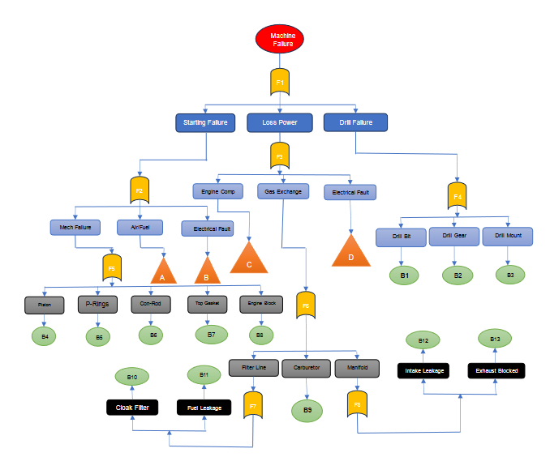

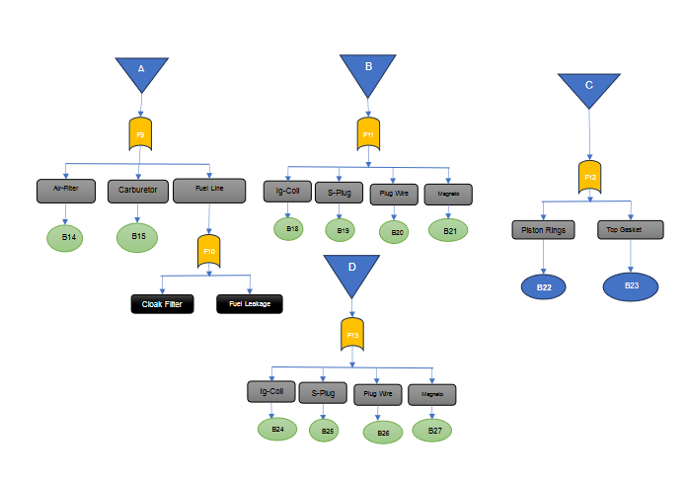

Figure 23 Fault Tree Diagram of ICE-Powered Drill

# APPENDIX B

**Failure Category: Non-Starting of Engine**

| **Component** | **Eng1** | **Eng2** | **Eng3** | **Eng4** | **Eng5** | **Tech1** | **Tech2** | **Tech3** | **Tech4** | **Tech5** | **User1** | **User2** | **User3** | **User4** | **User5** | **AI1** | **AI2** | **AI3** | **AI4** | **AI5** |
| --- | --- | --- | --- | --- | --- | --- | --- | --- | --- | --- | --- | --- | --- | --- | --- | --- | --- | --- | --- | --- |
| Spark Plug | 7 | 6 | 8 | 5 | 7 | 8 | 7 | 6 | 6 | 8 | 6 | 5 | 7 | 6 | 6 | 5 | 6 | 7 | 6 | 7 |
| Ignition Coil | 6 | 7 | 5 | 6 | 6 | 7 | 6 | 7 | 7 | 7 | 6 | 6 | 7 | 6 | 7 | 6 | 7 | 6 | 6 | 6 |
| Carburetor | 8 | 8 | 7 | 8 | 8 | 9 | 8 | 9 | 8 | 9 | 7 | 8 | 8 | 9 | 8 | 8 | 8 | 9 | 8 | 8 |
| Fuel/Air filter | 5 | 6 | 6 | 5 | 5 | 6 | 5 | 5 | 6 | 6 | 5 | 7 | 6 | 5 | 6 | 6 | 5 | 5 | 5 | 5 |
| Crankshaft | 6 | 7 | 6 | 6 | 7 | 7 | 6 | 7 | 6 | 7 | 6 | 6 | 6 | 6 | 6 | 6 | 6 | 6 | 7 | 6 |
| Piston | 7 | 8 | 7 | 7 | 8 | 8 | 7 | 8 | 7 | 8 | 7 | 7 | 7 | 7 | 7 | 7 | 7 | 8 | 7 | 7 |
| Piston Rings | 8 | 7 | 8 | 7 | 7 | 8 | 8 | 7 | 8 | 7 | 8 | 7 | 7 | 8 | 8 | 7 | 8 | 7 | 8 | 8 |
| Connecting Rod | 6 | 6 | 7 | 6 | 7 | 7 | 6 | 7 | 6 | 7 | 6 | 6 | 6 | 6 | 6 | 6 | 6 | 7 | 6 | 7 |
| Timing Settings | 5 | 5 | 6 | 5 | 6 | 6 | 5 | 6 | 5 | 6 | 5 | 5 | 6 | 5 | 6 | 6 | 5 | 5 | 5 | 6 |
| Cylinder Valve Damage | 7 | 7 | 8 | 6 | 7 | 8 | 7 | 7 | 7 | 8 | 7 | 6 | 7 | 7 | 7 | 7 | 7 | 7 | 7 | 7 |

**Failure Category: Low Power and Misfiring Engine**

| **Component** | **Eng1** | **Eng2** | **Eng3** | **Eng4** | **Eng5** | **Tech1** | **Tech2** | **Tech3** | **Tech4** | **Tech5** | **User1** | **User2** | **User3** | **User4** | **User5** | **AI1** | **AI2** | **AI3** | **AI4** | **AI5** |
| --- | --- | --- | --- | --- | --- | --- | --- | --- | --- | --- | --- | --- | --- | --- | --- | --- | --- | --- | --- | --- |
| Carburetor | 9 | 9 | 8 | 9 | 9 | 9 | 9 | 8 | 9 | 9 | 8 | 9 | 9 | 8 | 9 | 9 | 9 | 9 | 9 | 9 |
| Piston Rings | 8 | 8 | 9 | 8 | 8 | 8 | 8 | 9 | 8 | 9 | 8 | 8 | 8 | 9 | 8 | 8 | 9 | 8 | 9 | 8 |
| Spark Plug | 7 | 7 | 6 | 7 | 7 | 7 | 7 | 6 | 7 | 6 | 7 | 7 | 7 | 6 | 7 | 7 | 6 | 7 | 7 | 7 |
| Ignition Coil | 6 | 6 | 7 | 6 | 6 | 6 | 6 | 7 | 6 | 7 | 6 | 6 | 6 | 7 | 6 | 6 | 7 | 6 | 6 | 6 |
| Air Filter | 5 | 5 | 6 | 5 | 5 | 5 | 5 | 6 | 5 | 6 | 5 | 5 | 5 | 6 | 5 | 5 | 5 | 5 | 5 | 5 |
| Burnt Top Gasket | 6 | 6 | 7 | 6 | 6 | 6 | 6 | 7 | 6 | 7 | 6 | 6 | 6 | 7 | 6 | 6 | 7 | 6 | 7 | 6 |
| Crankshaft Bearings | 7 | 7 | 6 | 7 | 7 | 7 | 7 | 6 | 7 | 6 | 7 | 7 | 7 | 6 | 7 | 7 | 6 | 7 | 6 | 7 |
| Fuel Pipe and Filter | 8 | 8 | 9 | 8 | 8 | 8 | 8 | 9 | 8 | 9 | 8 | 8 | 8 | 9 | 8 | 8 | 9 | 8 | 9 | 8 |
| Oil Seal | 7 | 7 | 6 | 7 | 7 | 7 | 7 | 6 | 7 | 6 | 7 | 7 | 7 | 6 | 7 | 7 | 6 | 7 | 6 | 7 |
| Exhaust Manifold | 6 | 6 | 5 | 6 | 6 | 6 | 6 | 5 | 6 | 5 | 6 | 6 | 6 | 5 | 6 | 6 | 5 | 6 | 6 | 6 |
| Intake Manifold | 7 | 7 | 8 | 7 | 7 | 7 | 7 | 8 | 7 | 8 | 7 | 7 | 7 | 8 | 7 | 7 | 8 | 7 | 8 | 7 |
| Top Cylinder Valve | 6 | 6 | 7 | 6 | 6 | 6 | 6 | 7 | 6 | 7 | 6 | 6 | 6 | 7 | 6 | 6 | 7 | 6 | 7 | 6 |

#### **Normalize Ratings**

The sum of ratings for each expert group:

* **Engineer**: 99+90+117+81+96+111+111+96+81+105 = ***987***
* **Technician:** 70+58+86+56+58+76+76+66+56+74 = ***676***
* **User:** 30+30+40+29+30+35+37+30+27+34 = ***322***
* **AI:** 31+31+41+26+31+36+38+32+27+33 ***= 326***

**Spark Plug**:

* Engineer: 99/987 ​= ***0.1003***
* Technician: 70/676 ​= ***0.1035***
* User: 30/322 ​= ***0.0932***
* AI: 31/326 ​= ***0.0951***

#### **Weighted Average Ratings**

Weighted Average = 0.5 × Engineer + 0.3 × Technician + 0.1 × User + 0.1 × AI

For Spark Plug:

0.5×0.1003+0.3×0.1035+0.1×0.0932+0.1×0.0951= ***0.1003***

### **Normalize the Weighted Averages to Probabilities**

The sum of all weighted averages:

### **Computing Probabilities**

# APPENDIX C

**Bayesian Network**

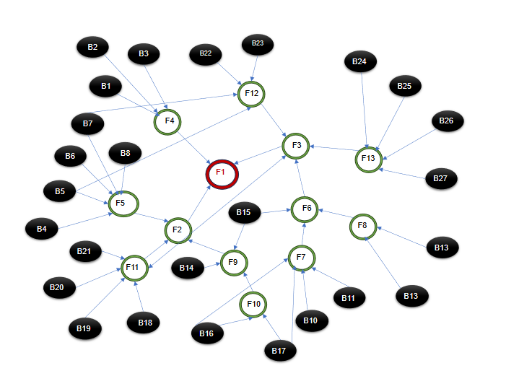

Table C. Bayesian Network Probability

|  |  |  |
| --- | --- | --- |
| BASIC EVENT | COMPONENT | PROBABILITY OF FAILURE |
| B1 | Drill Bit |  |
| B2 | Drill Mount |  |
| B3 | Drill Gear |  |
| B4 | Piston Non-Start | 0.1106 |
| B5 | Piston Ring Non-Start | 0.1106 |
| B6 | Connecting Rod Non-Start | 0.0944 |
| B7 | Top Gasket/ Valve Non-Start | 0.1049 |
| B8 | Engine Block/ Crankshaft | 0.0974 |
| B9 | Carburetor Power-Loss | 0.0875 |
| B10 | Fuel Filter Power-Loss | 0.0828 |
| B11 | Fuel Leak Power-Loss | 0.0828 |
| B12 | Intake Manifold Power-Loss | 0.0717 |
| B13 | Exhaust Manifold Power-Loss | 0.0678 |
| B14 | Air Filter Power-Loss | 0.0518 |
| B15 | Carburetor Non-Start | 0.1248 |
| B16 | Fuel Filter Non-Start | 0.0836 |
| B17 | Fuel Leak Non-Start | 0.0836 |
| B18 | Ignition Coil Non-Start | 0.0898 |
| B19 | Spark Plug Non-Start | 0.1003 |
| B20 | Coil Wire Non-Start | 0.0898 |
| B21 | Magneto/Settings Non-Start | 0.0836 |
| B22 | Piston Rings Power-Loss | 0.0828 |
| B23 | Top Gasket Power-Loss | 0.0593 |
| B24 | Ignition Coil Power-Loss | 0.0593 |
| B25 | Spark Plug Power-Loss | 0.0662 |
| B26 | Plug Wire Power-Loss | 0.0678 |
| B27 | Magneto Power-Loss | 0.0593 |

F1 = [F2, F3, F4]

F2 = [B4, B5, B6, B7, B8, B14, B15, B16, B17, B18, B19, B20, B21]

F3 = [B9, B10, B11, B12, B13, B22, B23, B24, B25, B26, B27]

F4 = [B1, B2, B3]

F5 = [B4, B5, B6, B7, B8]

F6 = [B9, B10, B11, B12, B13]

F7 = [B10, B11]

F8 = [B12, B13]

F9 = [B14, B15, B16, B17]

F10 = [B16, B17]

F11 = [B18, B19, B20, B21]

F12 = [B22, B23]

F13 = [B24, B25, B26, B27]

F2

F3

F4

F5

F11

F9

F10

F13

F6

F12

F8

F7

Fault Tree of Intermediate Events and Top Event